a. Select 2 game engines (1 mark) and list 4 reasons (1.5 marks each) why one particular game engine was selected (giving advantages of the game engine) and why the other was not selected.

Unity and Unreal engine are two of the most popular game engines. I used Unity as unmatched platform support. Unity supports 2D 3D and hybrid games effortlessly. The way the editor is structured, by setting scripts on objects, and the use of a high-level language, C#, makes it easy to learn. The editor GUI is very powerful and intuitive. It allows pausing gameplay It also has powerful asset management and attribute inspection.

b. Select 2 programming languages (1 mark) used in game development and choose one to support the game engine chosen and list 4 of its features (1.5 marks each)

With C#, you don’t have to worry much about garbage collection. C# programs are usually targeted towards the Windows operating system,

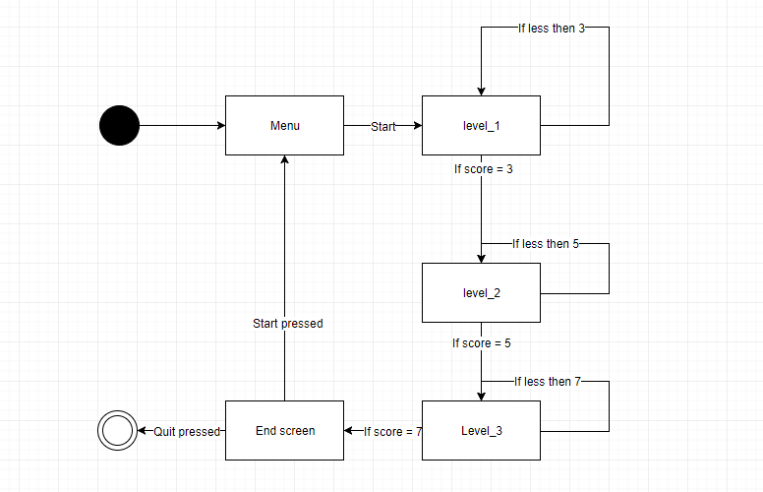

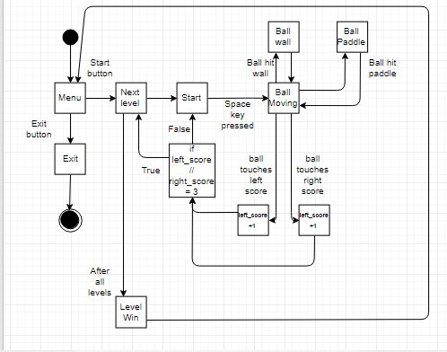

In not less than 100 words, explain why compression is needed when using media assets such as images, videos and audio. Provide examples.

Data compression is the process of reducing the amount of data needed for the storage or transition of a certain data. Compression is important in storing information on computer disks and in transferring data over communications networks. It reduces the size of the data and increases transition speed. File compression is mostly used when storing data in servers. As servers need a physical place to store data compressing files will make more space on the server to store more data and also reduces the time servers need to transfer data on the internet. File compression also can hide information that computers can’t decompress and stores it as indexes. This is helpful to transfer information which is not intended to the public.